**Chapter 5: Chemical Bonding**

**All Lectures Uploaded on YouTube:**

[**https://tinyurl.com/fkm9-chemistry**](https://tinyurl.com/fkm9-chemistry)



Most matter in the world is composed of compounds and their mixtures. Examples include human/animal/plant bodies, rocks, soil, petroleum, and coal. Compounds are formed when different kinds of atoms are bonded together.

A few elements (e.g., Noble Gases like Helium, Neon, Argon) exist as unbonded atoms. The properties of a substance (hardness, flexibility, stickiness) are directly determined by the nature of the bonding and the structure of its molecules.

**5.1. Why Do Atoms React?**

**The Octet and Duplet Rules (G.N. Lewis, 1916)**

These rules explain the reactivity and stability of atoms by focusing on their valence electrons.

**The Octet Rule:**

*An atom is most stable when its valence shell contains eight electrons.*

It applies to main group elements and involves only s and p electrons.

Examples: Oxygen, Nitrogen, and Carbon follow this rule.

Atoms gain, lose, or share electrons to achieve a full octet.

Sodium (Na): Unstable with an incomplete octet. Loses 1 electron to form Na⁺, which has the same electron configuration as Neon (Ne).

Chlorine (Cl): Unstable with an incomplete octet. Gains 1 electron to form Cl⁻, which has the same electron configuration as Argon (Ar).

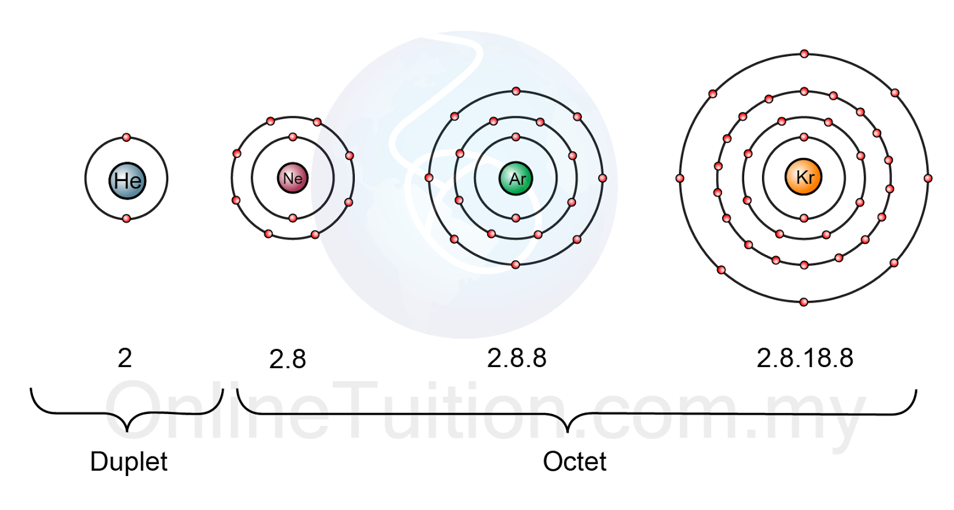

**The Duplet Rule**

The tendency of atoms to acquire a two-electron configuration (like Helium) in their outermost shell.

Applies to elements whose valence electrons are only in the s orbital (e.g., Hydrogen, Lithium, Beryllium).

Examples:

Lithium (Li): Loses 1 electron to form Li⁺ (`1s²`).

Beryllium (Be): Loses 2 electrons to form Be²⁺ (`1s²`).

**5.2. Chemical Bonds**

A chemical bond is a force of attraction that holds atoms together in a substance. These forces are electrical in nature.

Atoms (except Noble Gases) bond to achieve stability by attaining a noble gas electron configuration.

**Driving Forces for Bond Formation**

* Tendency to Lose Electrons (**Electropositive Nature**): Characteristic of metals. They have low ionization energy and low electronegativity. They lose electrons to form positive ions (cations). Example: `Na → Na⁺ + e⁻ .`Mg → Mg²⁺ + 2e⁻`
* Tendency to Gain Electrons (**Electronegative Nature):** Characteristic of non-metals. They have high electronegativity. They gain electrons to form negative ions (anions).
* Tendency to Share Electrons: Atoms can also achieve a noble gas configuration by sharing electrons with other atoms. This is the basis for covalent bonding.

**5.3. Types of Bonds**

Chemical bonds form when atoms interact with their valence electrons.

There are two main types: ionic bonds and covalent bonds.

**5.3.1. Ionic Bonding:**

* Ionic bonds are formed between a metal and a non-metal.
* This happens when one atom, typically a metal, loses one or more electrons to become a positively charged ion (a cation).
* Another atom, typically a non-metal, gains those electrons to become a negatively charged ion (an anion). Because they have opposite charges, the cations and anions are strongly attracted to each other by electrostatic forces. This powerful attraction is the ionic bond.
* The resulting compound is electrically neutral, meaning the total positive charge of all the cations balances out the total negative charge of all the anions.

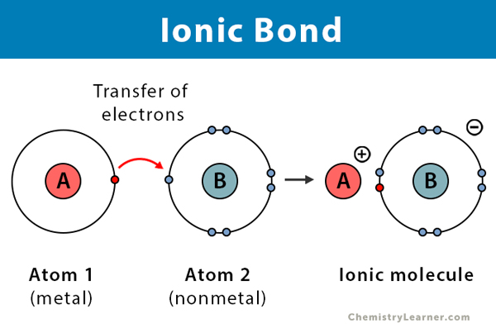

Ionic bonding between Na and Cl

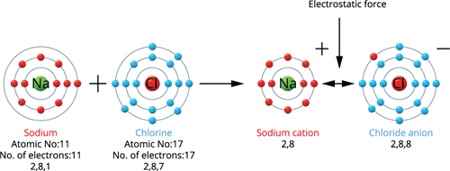

**5.3.2. Covalent Bonding:**

* Covalent bonds are formed between two non-metal atoms. Instead of transferring electrons, these atoms share pairs of electrons with each other.
* This sharing allows each atom to achieve a more stable electron configuration, often a full outer shell like a noble gas. The shared electrons are attracted to the nuclei of both atoms, creating a strong force that holds the atoms together.
* A single covalent bond is formed when one pair of electrons is shared. Sometimes atoms share two pairs (a double bond) or three pairs (a triple bond) to get the number of electrons they need. Electrons that are not shared and belong to only one atom are called lone pair

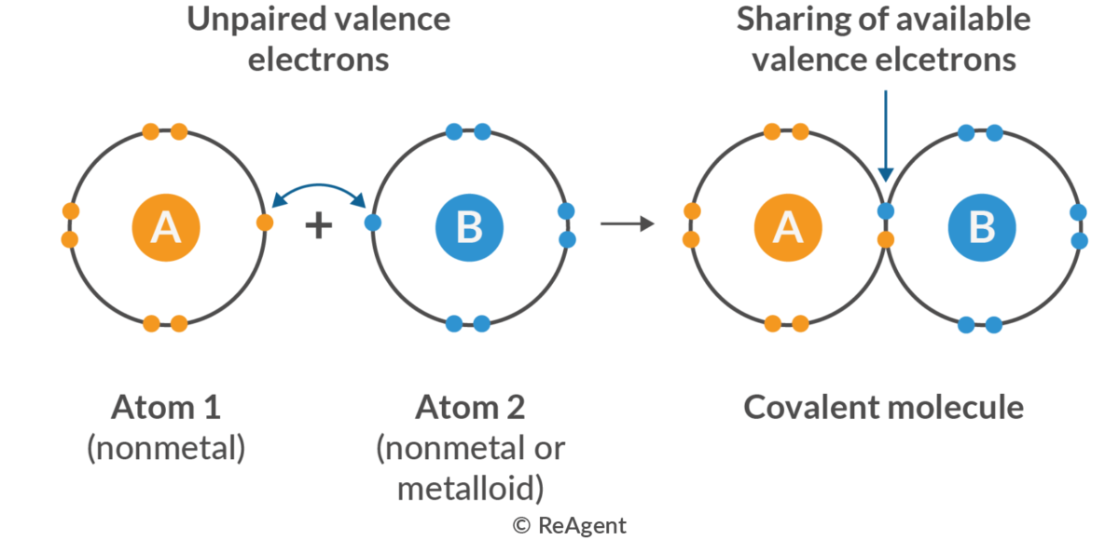

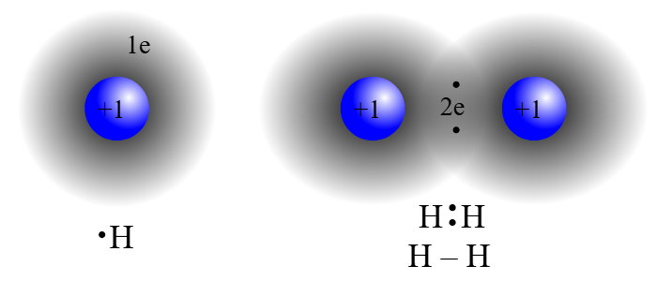

**5.3.3. Covalent Bonding: Polarity and Types**

A covalent bond is formed by the mutual sharing of electrons between two atoms, typically non-metals, to achieve stable noble gas electron configurations.

**Non-Polar Covalent Bond:**

* Forms between two **identical atoms** (e.g., H₂, N₂, O₂, Cl₂).
* The electronegativity of both atoms is equal, resulting in an **equal sharing** of the bonded electron pair.
* There is no separation of charge across the bond.

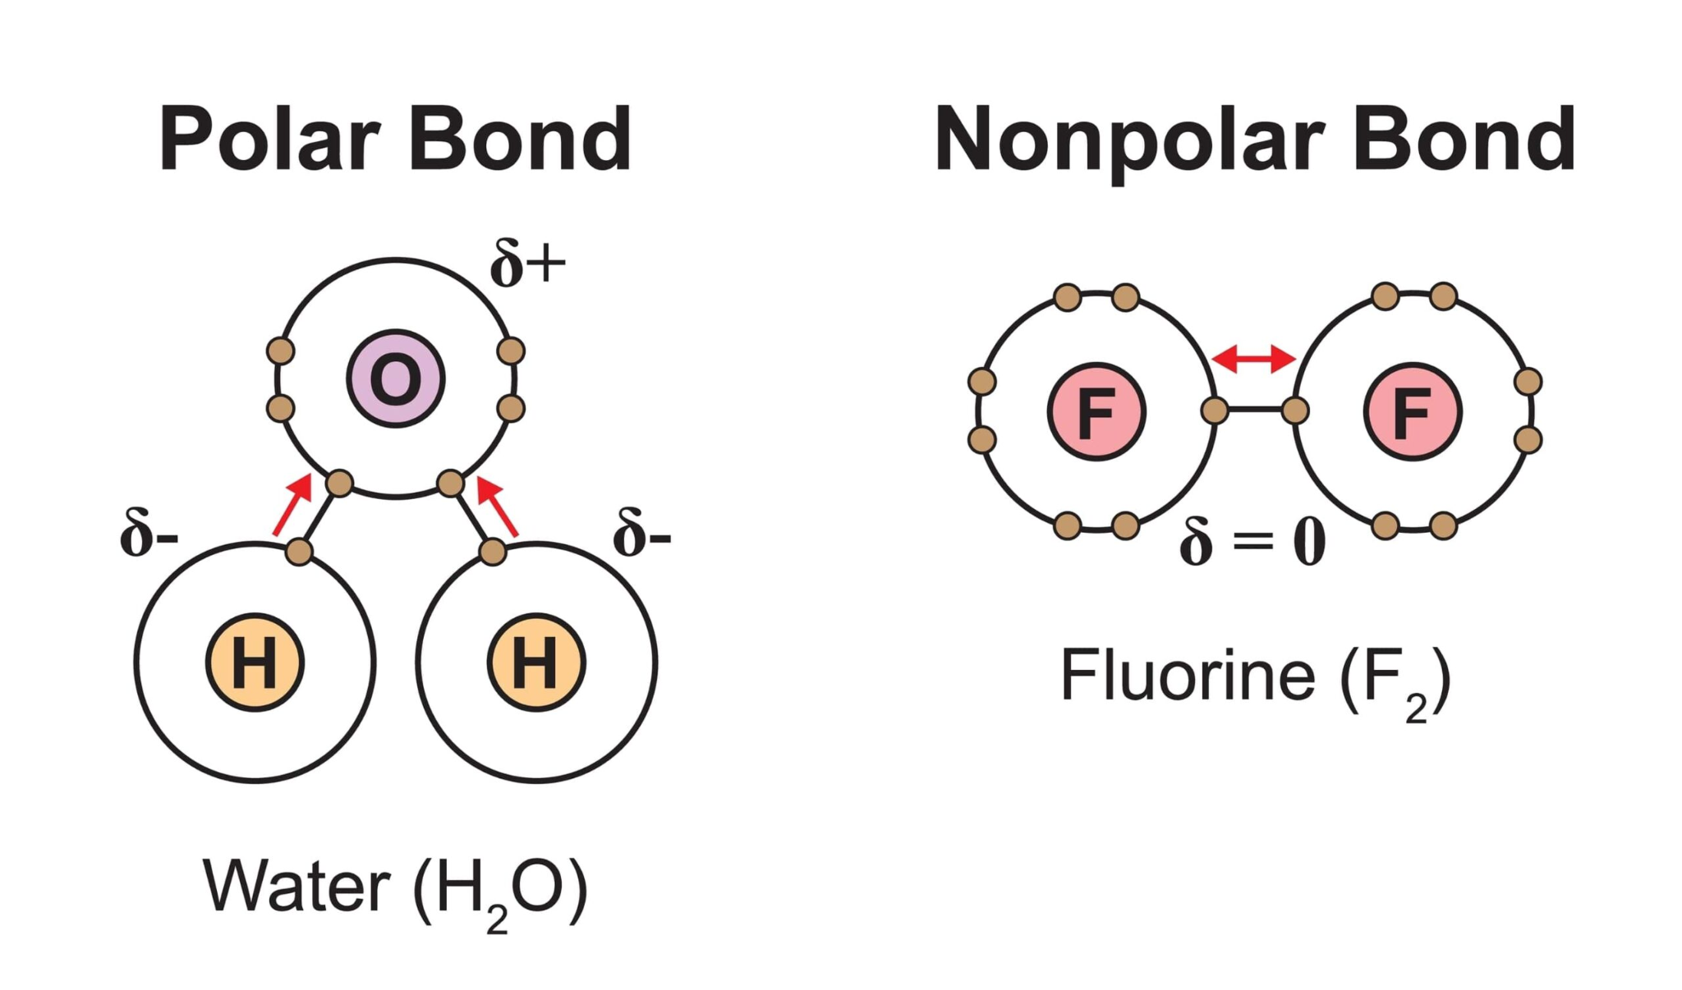

**Polar Covalent Bond:**

* Forms between two **different atoms** with different electro negativities (e.g., HCl, H₂O, NH₃).
* The more electronegative atom exerts a greater pull on the shared electron pair.
* This unequal sharing creates a **dipole**: the more electronegative atom becomes partially negative (δ⁻), and the other atom becomes partially positive (δ⁺).

**5.3.4. Coordinate Covalent (Dative) Bond:**

A special type of covalent bond where **both electrons** in the shared pair are **donated by a single atom** (the Lewis base). Once formed, it is identical to any other covalent bond.

**Ammonium Ion (NH₄⁺):** Formed when ammonia (NH₃) accepts a proton (H⁺). The nitrogen atom in NH₃ donates its lone pair to form the bond with H⁺, which contributes no electrons.

**Hydronium Ion (H₃O⁺):** Formed when a water molecule (H₂O) accepts a proton (H⁺). The oxygen atom in H₂O donates a lone pair to form the bond.

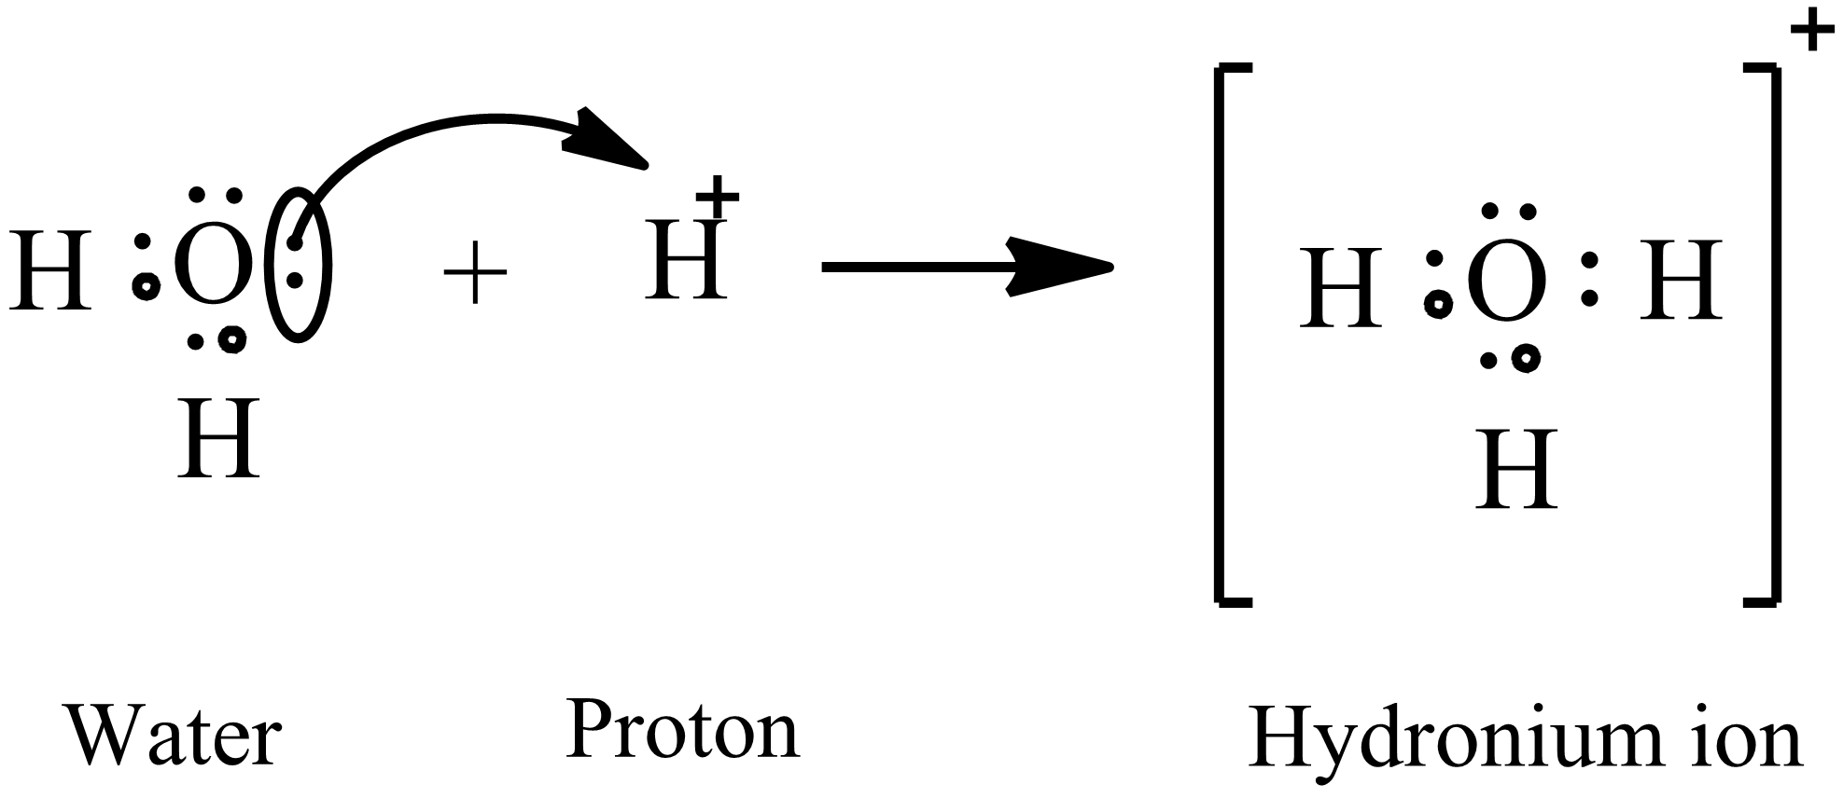

**Ammonia-Boron Trifluoride (NH₃·BF₃):** Boron trifluoride (BF₃) is electron-deficient. Ammonia (NH₃) acts as an electron-pair donor, with its nitrogen atom forming a coordinate bond with the boron atom.

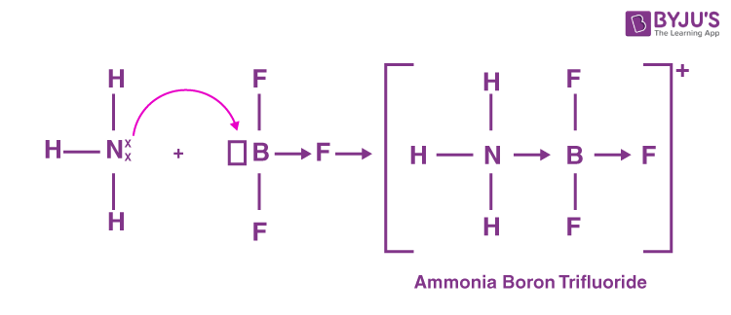

**5.4. Intermolecular Forces (IMFs)**

Intermolecular forces are attractive forces **between molecules**. They are significantly weaker than intramolecular chemical bonds (ionic/covalent) but dictate critical physical properties like boiling point, solubility, and surface tension.

**Dipole-Dipole Interactions:**

* Occur between the **positive end (δ⁺)** of one polar molecule and the **negative end (δ⁻)** of a neighboring polar molecule.
* These are electrostatic attractions that help hold molecules together in liquids and solids.
* **Practical Application:** The adhesive properties of many synthetic resins used in paints, dyes, and protective coatings for structures (bridges, vehicles) are largely due to dipole-dipole interactions forming linkages with the material surfaces.

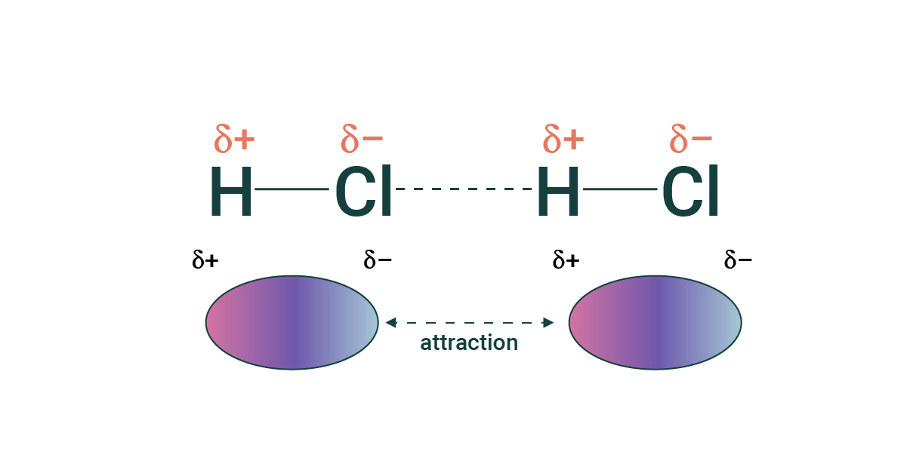

**Hydrogen Bonding:**

A **strong, special type of dipole-dipole interaction** occurs when a hydrogen atom is **covalently bonded** to a highly electronegative atom (**N, O, or F**). This hydrogen atom, with a significant partial positive charge, is then strongly attracted to a lone pair of electrons on another N, O, or F atom in a nearby molecule (or sometimes within the same molecule).

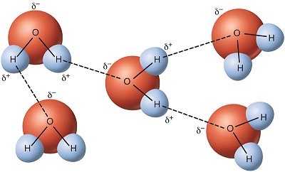

**Significance:** Hydrogen bonding is of paramount importance.

* It explains the unique properties of **water** (high boiling point, surface tension, ice being less dense than water).
* It is fundamental to the structure and function of **biological molecules** (e.g., the double helix of **DNA**, the folding of **proteins**).
* It is a key mechanism in the action of **adhesives, glues, paints, and synthetic resins**, where it provides strong binding between surfaces

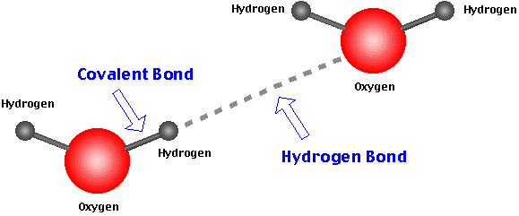

**5.5. Nature of Bonding, Structure and Properties**

The properties of a material (like its hardness, melting point, or if it conducts electricity) depend on three main things:

* What it's made of: Is it made of atoms, ions, or molecules? For example, a substance with ions (like salt) can conduct electricity when dissolved in water.
* How its parts are stuck together: The strength of the bonds between particles is crucial. Strong bonds (ionic, covalent, or metallic) make a substance hard and give it a high melting point (like diamonds or metal).Weak bond between molecules make a substance soft with a low melting point (like carbon dioxide gas).
* How the parts are arranged: The structure of the material matters. layers (like in graphite) can slide, making the material soft and useful for pencil lead. A 3D network (like in a diamond) makes a material extremely hard because all the atoms are locked in place.

**Electrical Conductivity**

Conductivity requires the movement of charged particles (ions or electrons).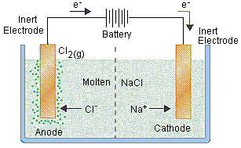

Ionic Compounds (e.g., NaCl):

* Solid State: Do NOT conduct electricity. Ions are locked in a fixed lattice and cannot move.
* Molten or Dissolved (Aqueous): DO conduct electricity. The lattice breaks down, allowing ions to move freely.

**Acids (Covalent but Ionize):**

* Pure acids are covalent and do not conduct.
* When dissolved in water, they ionize (e.g., HCl → H⁺ + Cl⁻), producing free-moving ions. Therefore, their aqueous solutions conduct electricity.

**Metals:**

* Excellent conductors due to a "sea" of delocalized electrons that are free to move.

Covalent Molecular Compounds (e.g., CH₄, H₂O):

* Do NOT conduct electricity (solid, liquid, or aqueous). They have no free ions or electrons; charged particles are held within covalent bonds.

**Melting & Boiling Points**

* Ionic Compounds (e.g., NaCl, NaF): Very High Melting/Boiling Points (e.g., NaCl: m.p. 801°C, b.p. 1455°C). Melting requires breaking the strong electrostatic forces (ionic bonds) holding the ions together in a giant lattice. This requires a large amount of energy.
* Covalent Molecular Compounds (e.g., H₂O, CH₄) : Low Melting/Boiling Points (e.g., Water: m.p. 0°C, b.p. 100°C; Methane: m.p. -183°C). Melting/boiling only requires overcoming the weak intermolecular forces between the molecules. The strong covalent bonds within each molecule remain intact. Breaking these weaker forces requires less energy.

**5.5.1. Graphite**

Graphite is a soft, black, slippery form of carbon (an allotrope) that feels greasy. Its name comes from a Greek word meaning "to write," which is why we use it in pencils.

* Its carbon atoms are arranged in flat, 2-dimensional sheets or layers.
* Inside each strong sheet, every carbon atom is strongly bonded to three others, forming hexagons.
* The secret to its properties is what holds these sheets together: very weak forces (Vander Waals forces). These layers can easily slide over each other.

**Why it's useful (because of its structure):**

* Slippery & Soft: The weak forces between layers allow them to slide, making it a great solid lubricant (like in locks) and the "lead" in pencils.
* Conducts Electricity: Unlike most non-metals, graphite conducts electricity. This is because one electron from each carbon is free to move along the sheets. This makes it perfect for electrodes in batteries and industrial furnaces.
* Heat Resistant: Its strong bonds make it stable at very high temperatures, so it's used to make heat-resistant bricks and parts in nuclear reactors.

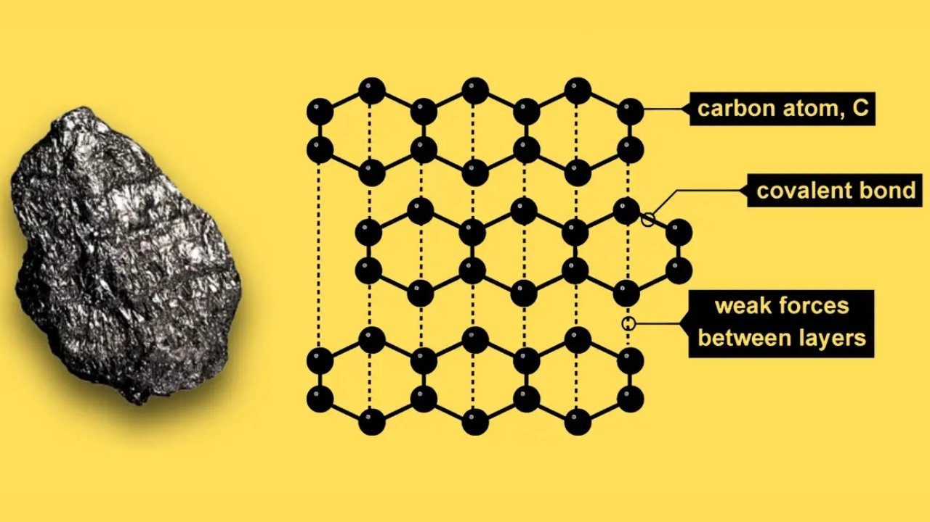

**5.5.2. Diamond**

Diamond is the hardest natural material known. It is a brilliant, transparent form of carbon where the atoms are locked into an incredibly strong 3D network.

* Each carbon atom is strongly covalently bonded to four other carbon atoms in a rigid, tetrahedral shape.
* This creates a giant, three-dimensional lattice that extends in every direction. Breaking a diamond means breaking these incredibly strong bonds.

**Why it's useful (because of its structure):**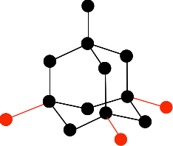

* Extreme Hardness: Its rigid 3D structure makes it the hardest material. It's used on the tips of drill bits, cutting tools, and grinding wheels to cut through other hard materials.
* Brilliance & Luster: After being cut and polished, diamonds brilliantly reflect light, making them prized for jewellery.
* Other Uses: Its properties also make it useful in specialized medical equipment, like surgical tools, and in high-quality sound equipment for DJs because it can vibrate very quickly without distorting.

**5.6. Metallic Bonding (e.g., Fe, Cu, Al)**

A "sea of delocalized electrons" surrounding a lattice of positive metal ions. The attraction between the electrons and ions is the metallic bond.

Properties:

* Malleable/Ductile: Layers of ions can slide without breaking because the electron sea holds everything together.
* Good Conductors: The delocalized electrons are free to move and carry charge/heat.
* High MP/BP: Strong metallic bonds.

#### 

